

December 2021
Welcome to the last issue of SPEAR News for the year.
This issue includes updates on the ePlan Portal launch and ePlan Pilot, new SPEAR signing application, handy hints, Digital Cadastre Modernisation program, Geographic Names Victoria and 2022 training dates for users.
The SPEAR team wishes all its stakeholders a peaceful festive season with family and friends. We hope 2022 is healthy and prosperous for all.

SPEAR updates

ePlan update

ePlan Portal launch
In October, Land Use Victoria (LUV) achieved a major milestone in the progress towards the adoption of ePlan by surveying firms in Victoria with the launch of the ePlan Portal in SPEAR.

The ePlan Portal houses the suite of all ePlan services, including the newly developed ePlan Creation Service and Single CAD Format File Validation Service, which surveyors can directly access from SPEAR to facilitate ePlan creation.

Embedding the ePlan Portal in SPEAR facilities end to end processes when combined with the SPEAR Electronic Lodgment Network (ELN), as conveyancers and lawyers can electronically lodge ePlans in SPEAR to LUV for registration.

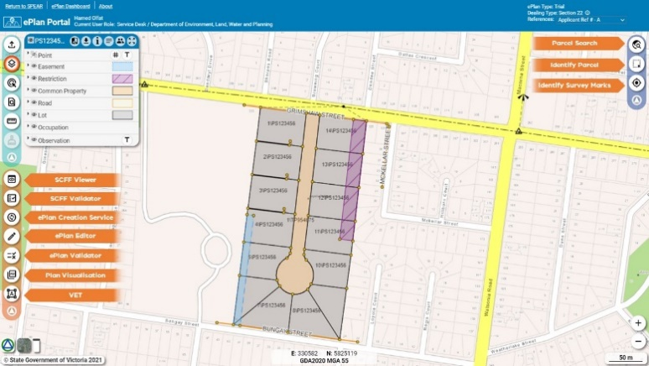
Broad engagement and collaboration with the surveying industry has been an integral part in the re-engineering of the ePlan portal. A series of ePlan webinars and engagement forums were held during the development phase.

Surveying firms that are ‘ePlan trained’ and have access to SPEAR are now able to manage their ePlans for land subdivisions within the ePlan Portal. This includes ePlan creation, validation, visualisation, visual enhancement and updating of plans.

This work is part of the new Digital Twin Victoria program’s ‘Faster Subdivision Registration’ workstream. This workstream aims to realise benefits for the property industry and government by streamlining title creation, electronic examination, and the development of a digital cadastral data distribution service.

This new digital infrastructure is also the connecting piece with the Digital Cadastre Modernisation program, enabling Victoria’s property boundary spatial data to be borne-digital, breaking the current cycle of pdf digitisation. The cadastral data of an ePlan can now be supplied by the licensed surveyor directly into SPEAR when the plan is initially submitted to council for certification.

ePlan Pilot
An ePlan Pilot with 13 Victorian surveying firms commenced in August. The pilot group attended initial training in July with the second formal session on 9 November. Pilot participants were able to access the ePlan Portal prior to the October release, providing the opportunity to familiarise themselves with the functionality and more importantly to provide feedback to the SPEAR team. This was a collaborative exercise that was extremely useful in the development of the ePlan Portal, with pilot participants identifying issues and suggestions for enhancements prior to the official launch.

The SPEAR team would like to acknowledge the following firms for their commitment, contribution, and enthusiasm since joining the pilot - Absolute Surveying, CAF Consulting, JH Surveying, Land Management Surveys, MNG Survey, Nobelius Land Surveyors, Paroissien Grant and Associates, Reeds Consulting, SMEC, Smith Land Surveyors, Taylors, Tomkinson Group and Veris.
The pilot will continue into 2022 with the aim of increasing participation from the surveying industry and increasing the uptake of ePlan.

SPEAR provides training and ongoing support to assist surveying firms transition to ePlan. Surveying firms interested in ePlan can contact the team via email – spear.info@delwp.vic.gov.au

SPEAR Electronic Lodgment Network
The SPEAR team reached another significant milestone in August in achieving 600 lodging parties signed up to the SPEAR Electronic Lodgment Network (ELN). There are a further 425 applications in progress.
The SPEAR ELN is now the primary method for conveyancers and lawyers to lodge plan-based dealings at LUV. Approximately 70% of Subdivision Act 1988 lodgments now come through SPEAR.
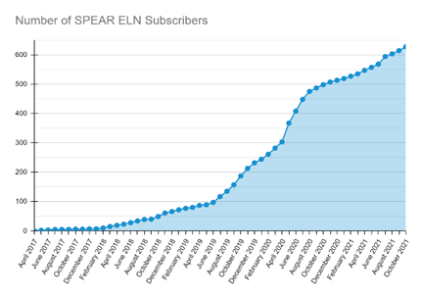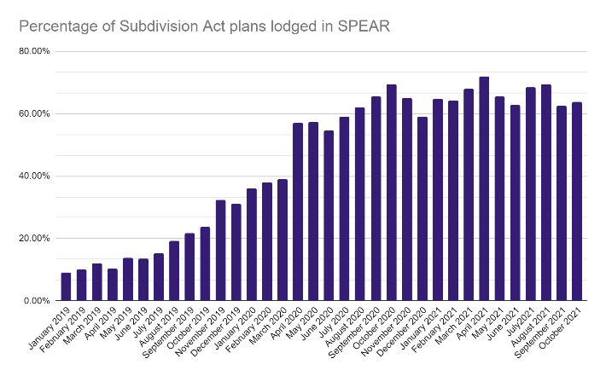

REMINDER – New SPEAR Signing Application
A new version of the SPEAR Signing Application was released in October 2021. The previous version of the Signing Application expires on 26 January 2022. All signing users including those with certificates installed on a token must download and install the new version to be able to sign. Instructions have been ​circulated via a SPEAR broadcast message. Please ensure you update to the new Signing Application prior to the Christmas break!

Digital Cadastre Modernisation program
LUV is digitising its archive of cadastral plans and surveys for every current land parcel in Victoria as part of its landmark Digital Cadastre Modernisation (DCM) work.
The digitisation process is capturing essential cadastral surveying data according to a comprehensive data model that will be used to maintain and improve the digital cadastre.
LUV is making this data available, as it’s captured, to interested surveying and geospatial professionals in digital format (LandXML) for early adoption and feedback. Visit our early data release webpage for more information and instructions on how to access the data.
Digital cadastral surveying data can now be accessed and re-used, eliminating the need for repeated manual data capture from plan and survey images. It is important to note that the data available on this platform is not the spatially upgraded, end-product data from digital cadastre modernisation. On the early data release page, you will be accessing the back captured survey measurements relating to each plan and survey that have been placed to match the existing Vicmap Property parcel structure.
If you have any questions on DCM email digital.cadastre@delwp.vic.gov.au

Geographic Names Victoria update

Naming rules for places in Victoria - 2021

Geographic Names Victoria (GNV) is in the final phase of preparing the revised Naming rules for places in Victoria (naming rules). It is anticipated that the revised naming rules will be released in December with stakeholder engagement workshops scheduled in February/ March 2022 to explain the new naming rules.

The review was undertaken over an 18-month period and saw engagement with over 700 stakeholders, three virtual workshops held with over 150 attendees and two stakeholder consultation periods for six and four weeks which received over 2,200 comments.

Enhancements to the naming rules will support greater diversity in naming, particularly of roads and places in developing areas. These include:

- additional information regarding link to place and support provided for naming themes
- allowing the use of first names in road naming
- connection to place for commemorative naming, reduced from 50 years to 25 years
- fast track the naming of features, i.e. parks in subdivisional areas.
VICNAMES - Bespoke polygons allows more names
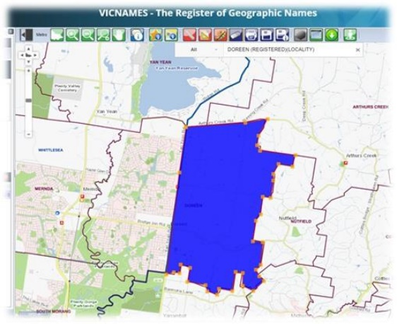
VICNAMES – the Register of Geographic Names is the portal to undertake duplication checks on names. Go to - https://maps.land.vic.gov.au/lassi/VicnamesUI.jsp

Duplication values of 5km, 15km, and 30km are assigned to individual localities within VICNAMES. Duplication is not allowed within the same locality or the prescribed values mentioned above. VICNAMES can now create bespoke duplication polygons. What does this mean? If a council has an increase in development within a specific area, GNV can draw a bespoke polygon, typically to reduce the duplication value from say 15km to 5km. This means more names will be available for use!
VICNAMES - Reporting diversity
VICNAMES now can report on whether a commemorative name applied to a road or place is named after a man, women, family, or someone who self-describes their gender. This supports the Gender Equality Act 2020 which sees public bodies having to report on policies and procedures to support gender equality. Some councils have or are in the process of undertaking an audit of road and place names to better understand the gender balance in its place names. This new functionality and the ability to flag whether a name is of Aboriginal origins will support reporting of diversity.
United Nations Decade of Indigenous Languages
The International Year of Indigenous Languages took place in 2019 and the United Nations proclaimed 2022 – 2032 to be the Decade of Indigenous Languages. GNV is in the process of identifying initiatives that will continue to encourage the use of Traditional Owner language.

It is anticipated that 2022 will see engagement with Traditional Owners to understand what they want to achieve and to seek support of proposed initiatives. If you have an idea for a project that supports Traditional Owners and encourages Traditional Owner language in the naming of roads, features and localities please contact GNV.

Handy hints

SPEAR ELN access vs. Guest access
Applicant Contacts are encouraged to phase out the use of Guest access to lodging parties. SPEAR lodging parties (ELN subscribers) should instead be included in an application using the ‘Nominate Lodging Method’ functionality.

The two types of access are not linked, and their functionality is very different:

- SPEAR ELN users have complete access to all applications associated with their firm and can use the system to build lodging forms, supply supporting information, digitally sign documents, and lodge applications to Land Use Victoria.
- Guest access is ‘view only’ and limited specifically to the individual whose email address was used in the invitation from the surveyor.
- Guest accounts are not linked within an organisation, meaning multiple users at the same firm cannot see applications that other staff have been granted guest access to. Guests are also unable to view applications in SPEAR past the point of ‘Lodged at Land Use Victoria’.

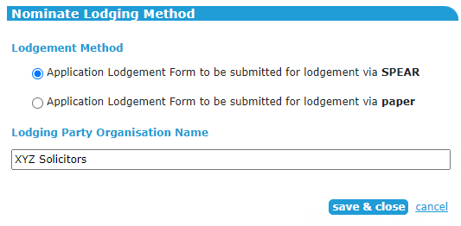
Applicant Contacts can ‘Nominate Lodging Method’ at any time after an application is ‘Lodged with Responsible Authority’ by using the optional action ‘Nominate Lodging Method’ and selecting the SPEAR lodgment option as opposed to paper lodgment. The SPEAR lodgment option requires the Applicant Contact to search for the lodging party by firm name, and then ‘save & close’, which triggers a notification to the lodging party advising them of their access to the application.

With over 630 active SPEAR ELN lodging parties now signed up to use SPEAR, it is highly recommended that the SPEAR lodgment option is selected by default, with the paper option only used in the absence of a matching firm name in the search.

For Applicant Contacts who have previously nominated an application as a ‘paper’ lodgment, but the lodging party has subsequently joined SPEAR, simply modify the lodging method form the Details screen and select ‘SPEAR’ as the lodgment method.

Responsible Authority action to close an outstanding referral
SPEAR allows the Responsible Authority to respond on behalf of a referral authority (RA). This may be required for several reasons:
- the referral response is overdue
- the referral was made to the incorrect authority
- the referral was not required
- the referral response was received outside of SPEAR
The Responsible Authority can add a response on behalf of the RA by selecting the ‘Add RA Response’ from the other actions list. The user must select the organisation they are responding on behalf of and pick the outstanding referral component(s) that their response is relevant to (i.e.: Section 55 - Planning Permit, Section 8 - Certification, Statement of Compliance).

The Responsible Authority user is then required to provide a response document (or justification) by either attaching a PDF or direct text entry. After authentication the response document will appear in Responsible Authority section of the Details screen with the following description:
RA Response (<Date,Time>, Closed by Resp Auth (Section 55 - Determining), Closed by Resp Auth (Certification), Closed by Resp Auth (SOC), <Referral Authority Name>)
The RA in question will no longer have a mandatory action to respond to that referral (or component of the referral).

SPEAR support

Video tutorials

Responsible Authority users
The SPEAR team have developed five video tutorials to assist new Responsible Authority users in their day-to-day use of SPEAR. The tutorials are listed below and are 5 – 7 minutes long. They should be your first reference when experiencing an issue, as you probably have the answer at your fingertips! If not, please contact the SPEAR Service Desk team spear.info@delwp.vic.gov.au.
- Navigating the Application List screen
- Maintaining the main tabs of a SPEAR application
- How does a Responsible Authority receive a new application in SPEAR?
- How does a Responsible Authority complete advertising instruction in SPEAR?
- How to authenticate SPEAR documents

Training
The following dates have been scheduled for our quarterly online training sessions in 2022. If you wish to attend, please register for a session by contacting the SPEAR Service Desk on (03) 9194 0612.
Lodging Party
Wednesday 9 February, Thursday 5 May, Wednesday 3 August, Thursday 3 November
Responsible Authority – council
Thursday 10 February, Wednesday 11 May, Thursday 4 August, Wednesday 9 November
Non-statutory referral authority
Thursday 10 February, Wednesday 11 May, Thursday 4 August, Wednesday 9 November
Applicant Contact
Wednesday 16 February, Thursday 19 May, Wednesday 10 August, Thursday 17 November
Statutory referral authority
Wednesday 16 February, Thursday 19 May, Wednesday 10 August, Thursday 17 November

Support
The SPEAR team strives to ensure your questions and issues are resolved quickly.
Contact the SPEAR Service Desk on (03) 9194 0612:
- Press 1 for SPEAR assistance
- Press 2 for Land Use Victoria subdivision lodgment enquiries
- Press 3 for ePlan enquiries
Alternatively, you can send your enquiry by email to spear.info@delwp.vic.gov.au

Contact SPEAR
T: 03 9194 0612
E: spear.info@delwp.vic.gov.au
W: www.spear.land.vic.gov.au

© The State of Victoria Department of Environment, Land, Water and Planning 2021
This work is licensed under a Creative Commons Attribution 4.0 International licence. You are free to re-use the work under that licence, on the condition that you credit the State of Victoria as author. The licence does not apply to any images, photographs or branding, including the Victorian Coat of Arms, the Victorian Government logo and the Department of Environment, Land, Water and Planning (DELWP) logo. To view a copy of this licence, visit http://creativecommons.org/licenses/by/4.0/
Disclaimer
This publication may be of assistance to you but the State of Victoria and its employees do not guarantee that the publication is without flaw of any kind or is wholly appropriate for your particular purposes and therefore disclaims all liability for any error, loss or other consequence which may arise from you relying on any information in this publication.
Accessibility
If you would like to receive this publication in an alternative format, please telephone the DELWP Customer Service Centre on 136186, email customer.service@delwp.vic.gov.au, or via the National Relay Service on 133 677 www.relayservice.com.au. This document is also available on the internet at www.spear.land.vic.gov.au.

